FORECASTING LOST SALES

The Carlson Department Store suffered heavy damage when a hurricane struck on August 31, 2000. The store was closed for four months (September 2000 through December 2000), and Carlson is now involved in a dispute with its insurance company about the amount of lost sales during the time the store was closed. Two key issues must be resolved: (1) the amount of sales Carlson would have made if the hurricane had not struck and (2) whether Carlson is entitled to any compensation for excess sales due to increased business activity after the storm. More than $8 billion in federal disaster relief and insurance money came into the county, resulting in increased sales at department stores and numerous other businesses. Table 1 gives Carlson's sales data for the 48 months preceding the storm. Table 2 reports total sales for the 48 months preceding the storm for all department stores in the county, as well as the total sales in the county for the four months the Carlson Department Store was closed. Carlson's managers have asked you to analyze these data and develop estimates of the lost sales at the Carlson Department Store for the months of September through December 2000. They also have asked you to determine whether a case can be made for excess storm-related sales during the same period. If such a case can be made, Carlson is entitled to compensation for excess sales it would have earned in addition to ordinary sales.

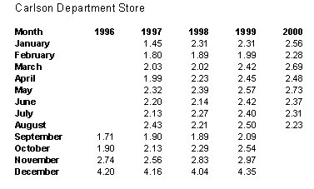

Table1. Carlson’s Sales.

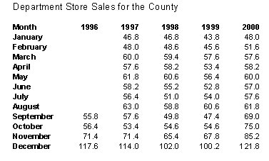

Table 2. Department Store Sales.

Managerial Report.
Prepare a report for the managers of the Carlson Department Store that summarizes your findings, forecasts, and recommendations. Include:
1. An estimate of sales had there been no hurricane.
2. An estimate of countywide department store sales had there been no hurricane.
3. An estimate of lost sales for the Carlson Department Store for September through December 2000.
In addition, use the countywide actual department stores sales for September through: December 2000 and the estimate in part (2) to make a case for or against excess storm related sales.

